Name: ___________________________________________________ Date: ______________

47

= %


Specialist 11- Unit 2

Test 4 - 2015

Topics: Trigonometric Functions

Total Time: 55 minutes Weighting: 4% of the year.

This test comprises of one section. All questions must be answered in both sections. Answers should be rounded to 2 decimal places unless specified. All working should be shown in the space provided. Solutions without working may not be awarded full marks. Please take the marks for each question into account when answering the question.

SECTION 1: CALCULATOR FREE

Time: 55 minutes Equipment Allowed: Formula sheet

- [7 marks: 2, 2, 3]

i. Expand and simplify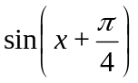.

ii. Express 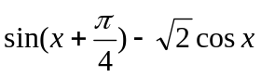 exactly in the form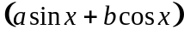, where and are real numbers.

iii. Solve: 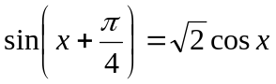, for 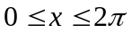.

2. [4 marks]

Solve 2 − 2 cos² x − 3 sin x = 2 for −90° ≤ x ≤ 90°

3. [6 marks]

Use appropriate trigonometric identities to solve sin4x = sin2x between
0 and 360⁰.

4. [4 marks: 2, 2]

Evaluate:

i. cos75⁰cos15⁰.

ii. 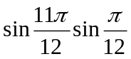

5. [3 marks]

Prove that cos θ sin 2θ = 2 sin θ − 2 sin³ θ

6. [6 marks: 2, 2, 2]

Rewrite each of the following as an expression involving a single trigonometric function.

i. 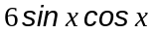

ii. 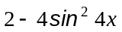

iii. 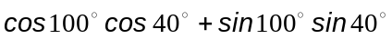

7. [8 marks: 2, 2, 2, 2]

From the graphs below, determine the equation of the function.

i. 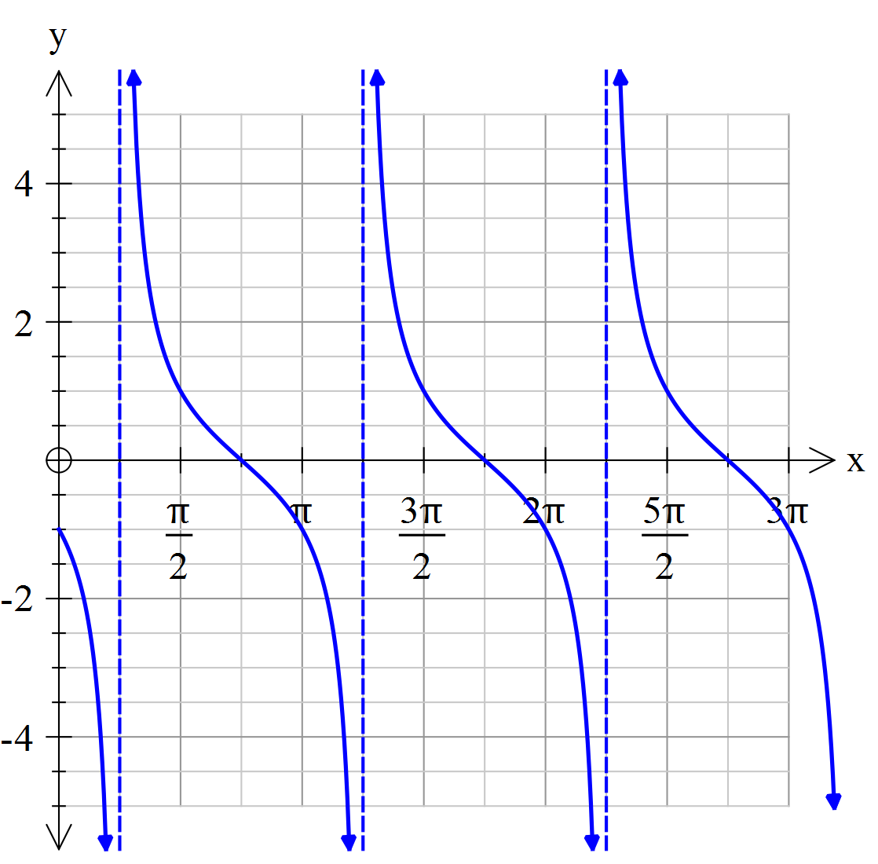 ii. 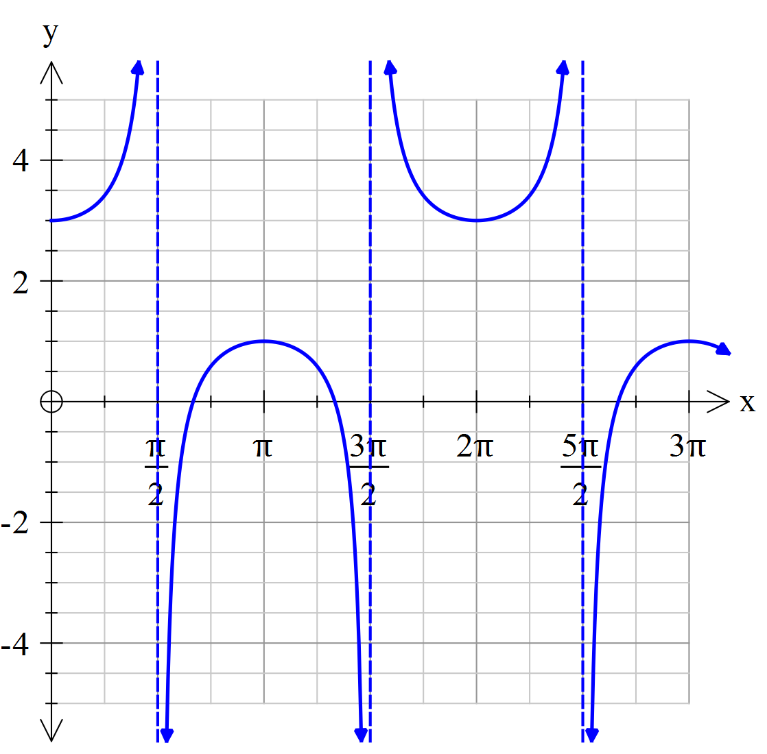

iii. 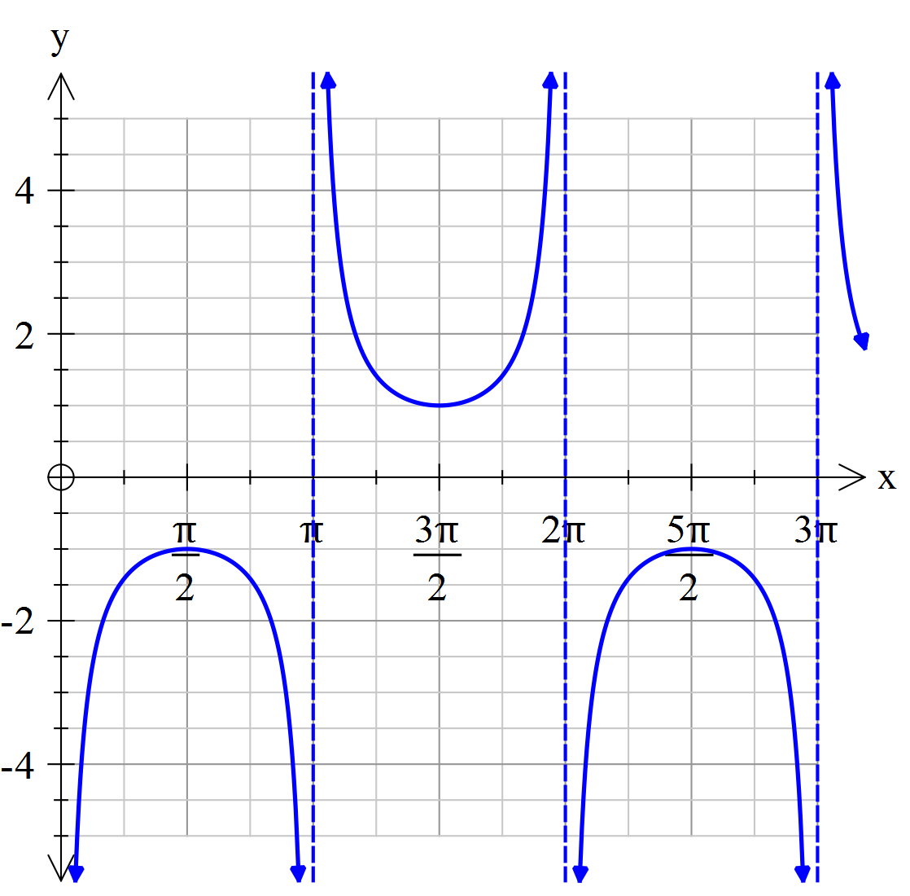 iv. 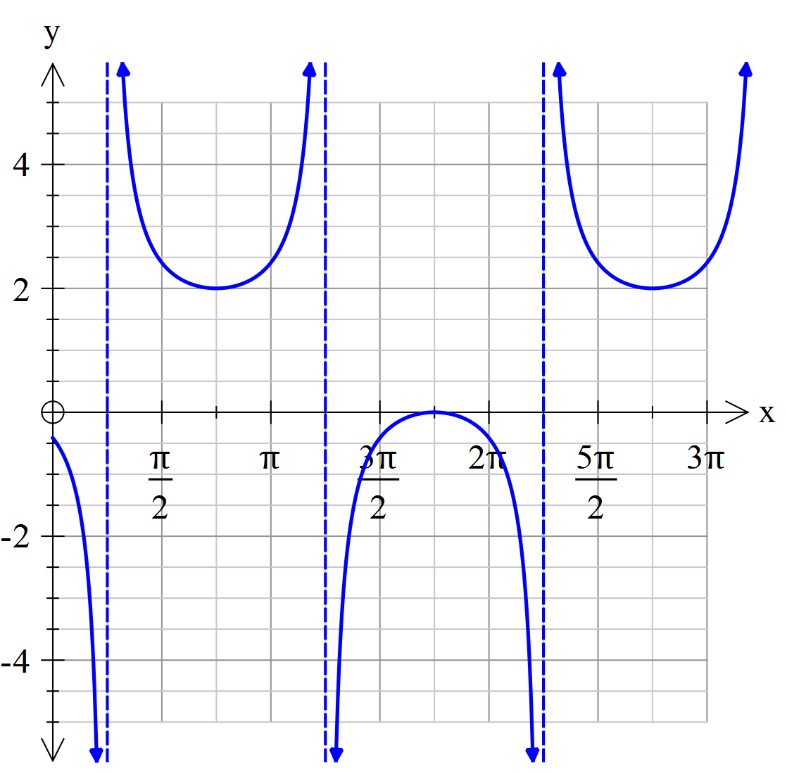

8. [4 marks]

Prove that 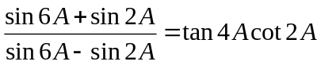

9. [5 marks]

State the period and amplitude of the following functions.

Function | Period | Amplitude
y = sin x
y = sin (x+2)
y = ½sin (x+2)
y = sec (3x+2)
y = cot ½(x+2)

END OF TEST

